Lister BCC

**Mail Storage Administration**

Software Design Document

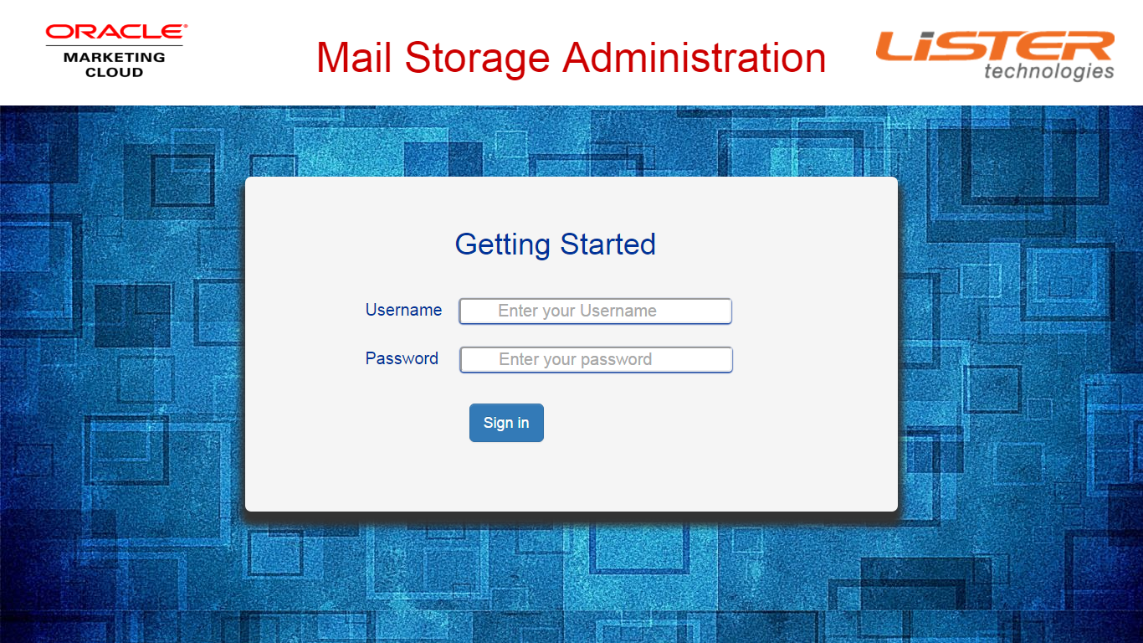

Name : Souvik Dutta Choudhury

Date: 25/11/2016

**TABLE OF CONTENTS**

**1. INTRODUCTION 2**

1.1 Purpose

1.2 Scope

1.3 Overview

**2. SYSTEM OVERVIEW 2**

**3. SYSTEM ARCHITECTURE 2**

3.1 Architectural Design 2

**4. DATA DESIGN 3**

4.1 Data Description 3

4.2 Data Dictionary 3

**5. COMPONENT DESIGN 3**

**6. HUMAN INTERFACE DESIGN 4**

6.1 Overview of User Interface 4

6.2 Screen Images 4

6.3 Screen Objects and Actions 4

**7. REQUIREMENTS MATRIX 4**

**8. APPENDICES 4**

**1. INTRODUCTION**

**1.1 Purpose**

The purpose of this project is to access the file system used to store client emails and made necessary retrievals and changes there to help the clients to retrieve necessary information from the file system without extensive search so that they can track the email information from the file system.

**1.2 Scope**

Following are the goals of the project:-

• Ability to see client’s BCC address, current storage location, number of mails, credentials if any,space consumption

• Ability to modify the above

• Restrict access of folders to clients

• Restrict access of feature (Edit/modify) based on user role

• Ability to easily on-board a customer which would require the application to create the storage location and necessary permissions. Storage location can be sub-divided into sub-folders based on geography or sub-accounts.

• Application should be able to connect to Linux and AWS S3 storage systems

• Application should be able to perform archival and cleanup activities

• User should be able to search the emails using email address (from/to) or subject

**1.3 Overview**

This documents shows the overall design of the project starting from its architecture,data design,components and UI/UX design in the form of flowcharts,diagrams and contents.

1. **SYSTEM OVERVIEW**

**2.1 Assumptions**

The system is an auxiliary application to support the **existing mail client application** of the organization which is designed to have a user interface for the clients where they can store their mails to the mail folders assigned to them.

**2.2 General Overview**

This application facilitates the admin of Lister the creation of those folders and restricting a particular client to a particular set of folders.It also allows a section of admins to onboard the clients by registering their basic information and assigning them folders in the file system of Lister.Here the users can search the emails sent by a particular client by feeding its userid and password.

The system is built on JAVA Spring MVC framework and it uses file system to store data. The basic access credentials are stored in Oracle RDBMS.

**3. SYSTEM ARCHITECTURE**

**3.1 Architectural Design**

The following diagram shows the high level flow of control where the user interacts with the user interface which inturn interacts with the remote server through the application layer. The remote server fetches data and/or registers data to the remote file system metadata and returns to the operating system of the client machine and displays the desired output at the client end.

**TestTemplate (1)**

**4. DATA DESIGN**

**4.1 Data Description**

The data is stored as metadata in the file system itself along with the mail storage folders.This saves a lot of retrieval complexity compared to storing it in any RDBMS.

Since the access permissions are strictly restricted to specified users,it is also very secure since the metadata will be affected only by the MSA application and not by any other means.

The data transfer communication with the file system is made using **SSH File Transfer Protocol** (SFTP).

The SFTP credentials are fetched from Oracle RDBMS to establish the connection to the file system.

**4.2 Data Dictionary**

|  |  |  |
| --- | --- | --- |
| **Element** | **Attribute** | **DataType** |
| User | Username | String |
| Password | String |
| Role | String |
| Access | Role | String |
| Permission | List |
| Permission | Super User | Boolean |
| IT Support | Boolean |
| Email Support | Boolean |
| Folder | Id | Integer |
| Name | String |
| Parent | Integer |
| Client | Integer |
| Path | String |
| Client | Id | Integer |
| Name | String |
| BCC address | String |
| Directory | Integer |
| No of Mails | Integer |
| Space Occupied | Integer |
| Mail | Token | Integer |
| Description | String |
| Sent Date | Date |
| Location | String |

1. **COMPONENT DESIGN**

The various components of the application on a wide scale are:-

* **Spring MVC Dispatcher Servlet**:- It maps the various controllers and beans to the Java Application and helps the application to integrate the various modules.
* **Controller:-** It maps controls the entire flow of process by processing every URL request and performing necessary action corresponding to that request.
* **Domain:-** It contains all the necessary **POJOs** for Repository Objects.It contains all the basic templates for all the JSON objects in the meta data JSON files.
* **Repository:-** It contains template for every **Json** file in the database.Whenever a service needs to fetch a data from the database,it creates a repository object and maps it to the Json file.
* **Service:-** They are called by the controllers to do some action.They link the Repositories with the File System Metadata and also maps them to repository objects using **Jackson API**.

Component (1)